**Notes**

# Basics

## Scraping

* 2 big reasons that it can fail
  + Websites use programs to block access
  + Website uses JavaScript
* To take the symbol from the front of a price, you need to take the whole price other than the first character
  + Variable = variable_with_symbol[1:]

## Methods

* str() – converts to string
* int() – converts to int
* can use {} to be a placeholder
  + ex:

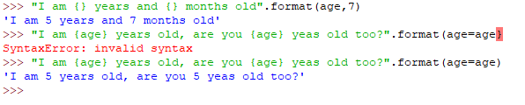

* + format method has a pdf in this folder that gives more uses for it
* input() – use this method to get user data

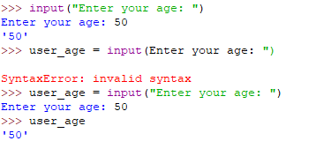

* To create a new method, use the **def** keyword

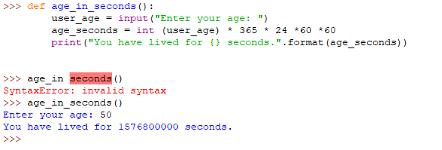

* If, else, elif
  + 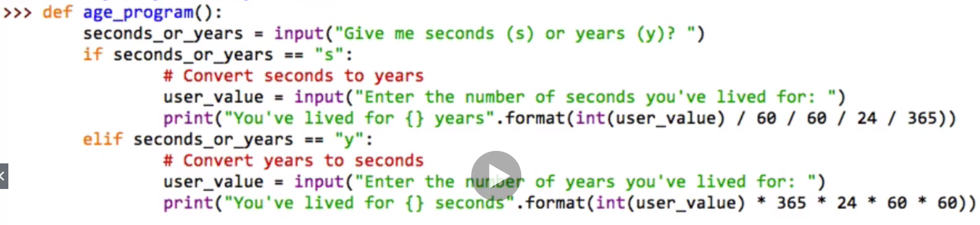

# Databases

## MongoDB

* Uses Json data for the tables
* When starting it up, start up the database first by going to the installation folder and going to the command prompt then typing mongod.exe
* Once you do, the database will start and begin listening
* Then you can start a separate cmd and type in mongo and then you can write commands to the database
* Below, you will see a few commands that I typed in

